NC CITIZEN SUNDAYS

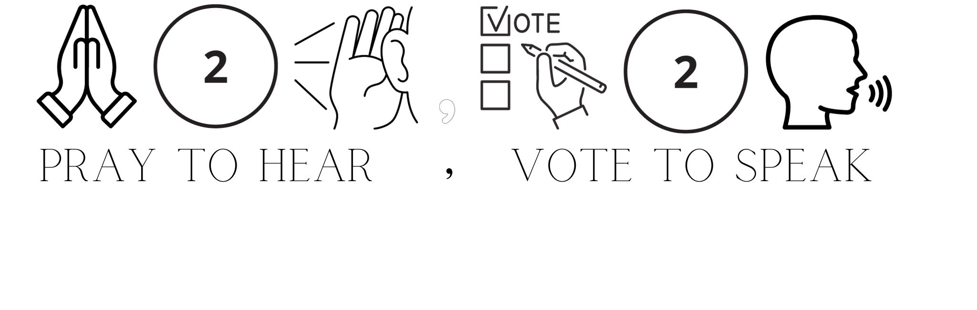Pastor Prayer Points:

“I exhort therefore, that, first of all, supplications, prayers, intercessions, and giving of thanks, be made for all men; For kings, and for all that are in authority; that we may lead a quiet and peaceable life in all godliness and honesty.”
1 Timothy‬ 2‬:1‬-2‬ KJV‬‬

•THE PRIORITY: “I exhort …first of all…prayers be made..”

As obedient Christian Citizens prioritize prayer, as an act of obedience, to a biblical exhortation that is essential, not optional.

•THE PLAN: “‘…for ALL that are in authority.”

Obeying God’s plan produces His results. Ignoring His plan produces man-made results. As obedient Christian Citizens enter your private prayer closet to hear from God. Then register to vote, and move towards the ballot box, to speak for God, in the public square. Do both.

•THE PRODUCT: “…that we made lead a quiet and peaceable life in all godliness and honesty.”

Be honest to God. Have you seen too much of God’s results lately? This is not a trick question.

Prayerfulness produces God’s results. Prayerlessness produces man-made results.

“Lord teach us to pray.” Luke 11:1

“Delayed obedience is still disobedience.” Henry Blackaby

